
Date | 30 September 2026
Team ID | SWTID-2026-3972
Project Name | Import Data using Transform Maps (Spreadsheet)
Team Leader | Kartheeswaran M
Team Member | Karuppasamy A
 | Mari Muthu G
 | Irfan U
Maximum Marks | 5 Marks

Project Title:
Import Data using Transform Maps

7. Project Documentation Phase

This document serves as the comprehensive guide detailing the end-to-end execution of the "Import Data using Transform Maps" project. It covers the rationale behind the automation, the structural design of tables and maps, the development steps taken within the ServiceNow instance, and the testing procedures that validate data integrity. The documentation ensures that the process is reproducible and easily understandable for future administrative tasks.

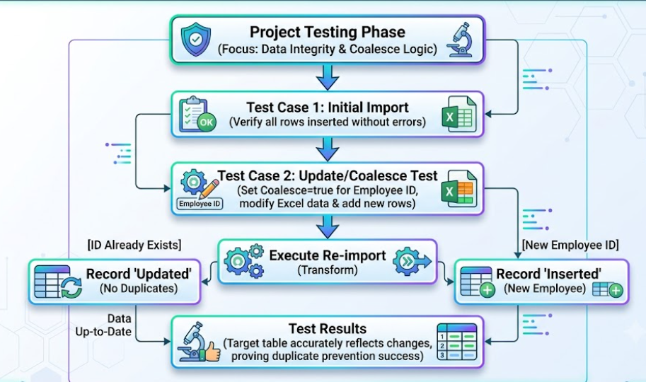

Screenshot:

